1.Student marks creation
import csv
file=open("student_marks.csv","w",newline="")
writer=csv.writer(file)
writer.writerow(["regno","name","department","python marks","data science marks"])
n=int(input("Enter the number of students: "))
for i in range(n):
reg=input("Enter the registration number: ")
name=input("Enter the name:")
dept=input("Enter the department: ")
python_marks=int(input("Enter the python marks: "))
ds_marks=int(input("Enter the data science marks: "))
writer.writerow([reg,name,dept,python_marks,ds_marks])
file.close()
print("\n Student Details.")
file=open("student_marks.csv","r")
reader=csv.reader(file)
for row in reader:
print(row)
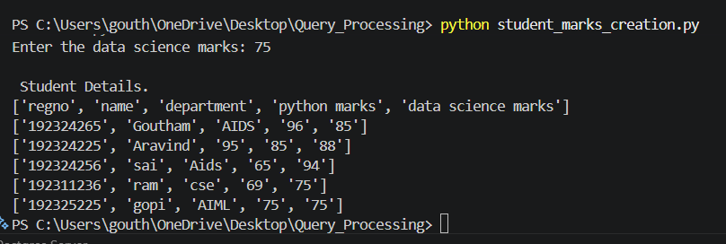

2. CSV File: Employee Database
import csv
file=open("employee.csv","w",newline="")
writer=csv.writer(file)
writer.writerow(["employee_id","employee_name","department","designation","salary"])
n=int(input("Enter the number of employees: "))
for i in range(n):
id=input("enter employee id: ")
name=input("enter employee name: ")
department=input("enter employee department: ")
designation=input("enter employee designation: ")
salary=input("enter employee salary: ")
writer.writerow([id,name,department,designation,salary])
file.close()
print("/n Employee Details.")
file=open("employee.csv","r")
for row in csv.reader(file):
print(row)
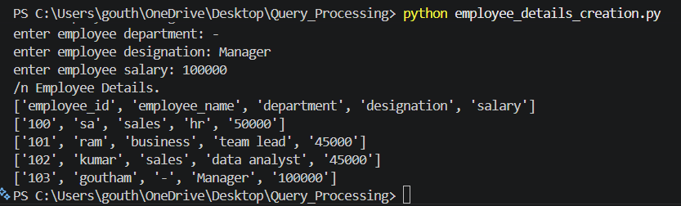

3. JSON File: Faculty Information System
import json
faculty=[]
n=int(input("Enter the number of faculty members:"))
for i in range(n):
data={
"faculty_id": input("Enter faculty ID: "),
"faculty_name": input("Enter faculty name: "),
"department": input("Enter department: "),
"designation": input("Enter designation: "),
"Experience": input("Enter experience: ")
}
faculty.append(data)
file=open("faculty.json","w")
json.dump(faculty,file,indent=4)
file.close()
print("Faculty Details.")
file=open("faculty.json","r")
for row in json.load(file):
print(row)
file.close()
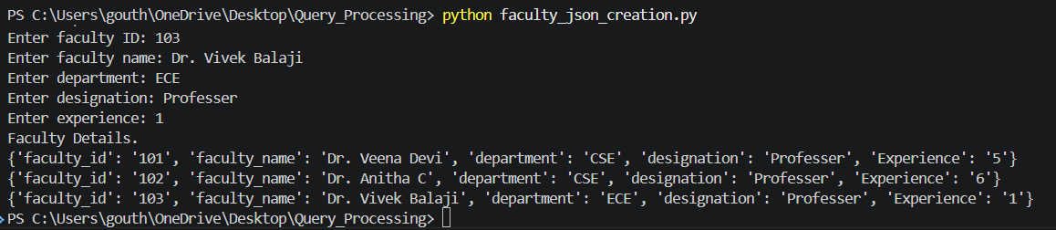

4.
import json

products = []

for i in range(2):
data = {
"ID": input("Product ID: "),
"Name": input("Product Name: "),
"Category": input("Category: "),
"Price": input("Price: "),
"Quantity": input("Quantity: ")
}

products.append(data)

file = open("products.json", "w")
json.dump(products, file, indent=4)
file.close()

print("\nProduct Details")

for p in products:
print(p)

5.
import xml.etree.ElementTree as ET

courses = []

root = ET.Element("Courses")

for i in range(2):

code = input("Course Code: ")
name = input("Course Name: ")
credit = input("Credits: ")
dept = input("Department: ")
faculty = input("Faculty Name: ")

course = ET.SubElement(root, "Course")

ET.SubElement(course, "Code").text = code
ET.SubElement(course, "Name").text = name
ET.SubElement(course, "Credits").text = credit
ET.SubElement(course, "Department").text = dept
ET.SubElement(course, "Faculty").text = faculty

courses.append([code, name, credit, dept, faculty])

tree = ET.ElementTree(root)
tree.write("courses.xml")

print("\nCourse Details")

for c in courses:
print(c)

6.
import xml.etree.ElementTree as ET

patients = []

root = ET.Element("Patients")

for i in range(2):

pid = input("Patient ID: ")
name = input("Patient Name: ")
age = input("Age: ")
disease = input("Disease: ")
doctor = input("Doctor Name: ")

patient = ET.SubElement(root, "Patient")

ET.SubElement(patient, "ID").text = pid
ET.SubElement(patient, "Name").text = name
ET.SubElement(patient, "Age").text = age
ET.SubElement(patient, "Disease").text = disease
ET.SubElement(patient, "Doctor").text = doctor

patients.append([pid, name, age, disease, doctor])

tree = ET.ElementTree(root)
tree.write("patients.xml")

print("\nPatient Details")

for p in patients:
print(p)

